**WEEK-4**

**SPRING REST using SPRING BOOT 3  
JWT Handson**

**Create authentication service that returns JWT**

**CODE:**

**Step-1: Creating Spring Boot Project**

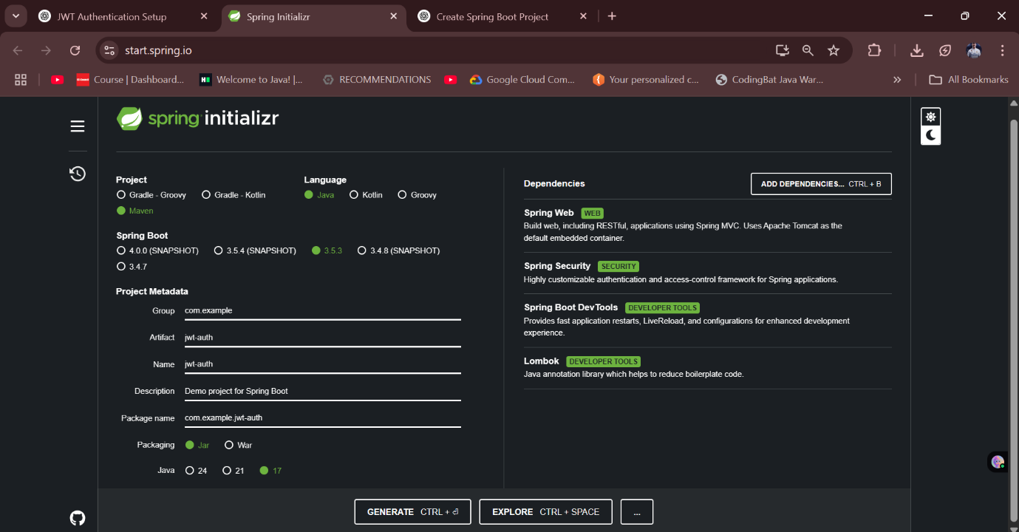

**Step-2: Adding JWT Dependency to pom.xml and running it**

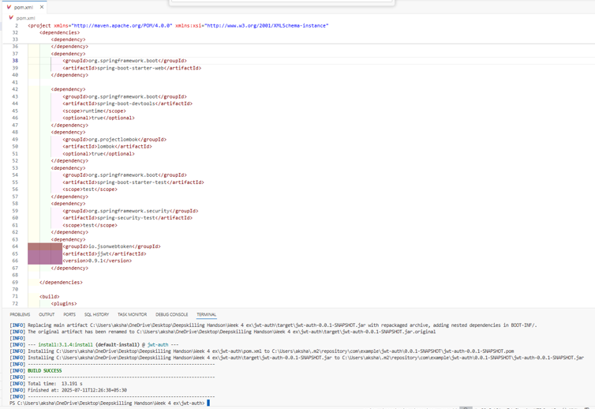

**Step-3: File Structure Overview**

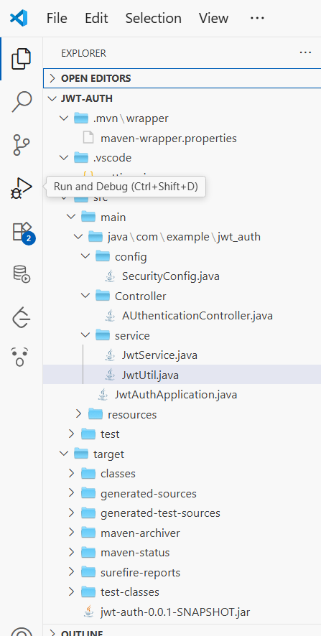

**Step-4: Creating AuthenticationController.java**

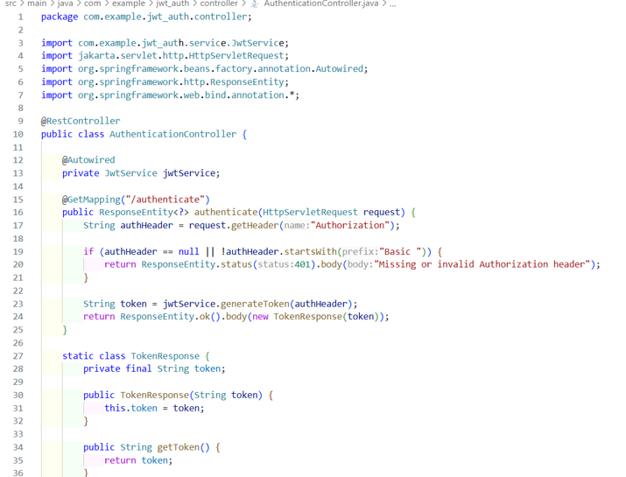

**Step 5: Creating JwtService.java**

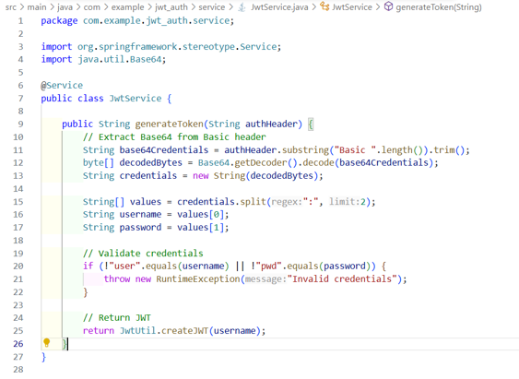

**Step-6: Creating JwtUtil.java**

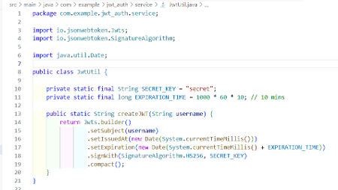

**Step-7: Creating SecurityConfig.java**

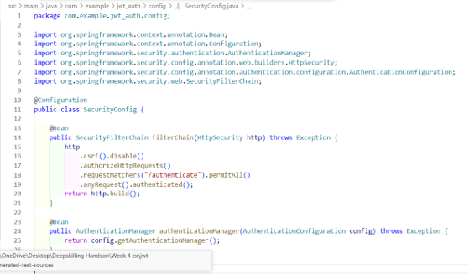

**Step-8: Running and Testing**

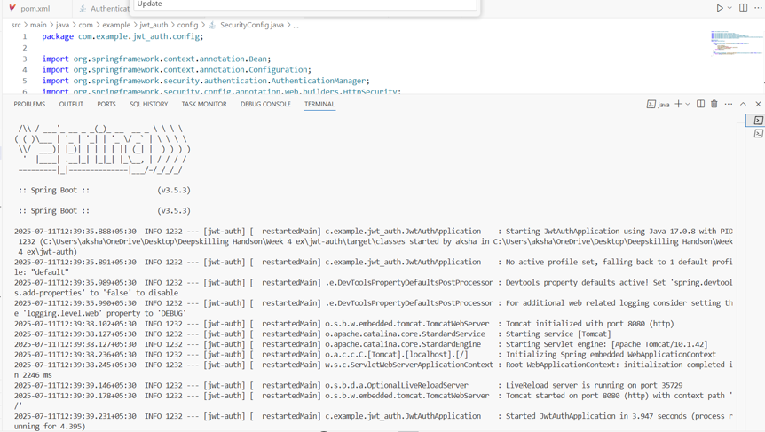

Output->

